

**PROJECT REPORT**



# **Online News Popularity Prediction**



**“Submitted towards partial fulfillment of the criteria for award of PGPDSE by GLIM”**

**Submitted by**

|  |  |
| --- | --- |
| **Student Name** | **SIS ID** |
| Abhisar Narkhede | BEK0HX0HMC |
| Ameer Khan | ZVDDGGU36F6 |
| Deepak Shende | 2KL0EZD9CG |
| Sneharth Bhajani | 0FMU4ZJK6L |
| Sharmistha Ghosh | TWOXU47B04 |
| Vishnu .P.S | 7ECZOAXVRJ |

**Batch: DSE_BLR_AUG2019**

**Mentor: Mr. Srikar Muppidi**



 **Abstract:**

# Abstract & keywords

### In this modern arena of online news on social media and online news channels the news articles with various online contents that captures the attention of Internet users as it gives in short description of the topics and that brings out the curiosity in the user to know more about the news and get in-depth knowledge of the topic. This article is particularly enjoyed by mobile, desktop users and are massively spread through online social media platforms. As a result, there is an increased interest for discovering the articles that will become popular among users over the internet. This objective falls under the broad scope of content popularity prediction and has direct impact on the development of new services for online advertisement and content distribution. Our aim is to predict the popularity of an articles based on how many times an article is been shared. There are both positive articles and negative articles which are been analyzed with text mining methods. Here, we are predicting that how popular will the article be when it has image, videos, contents, on which days of the week the share is more and which main topic is getting shared to maximum by analyzing this features we will develop a machine learning model that gives prediction of news popularity on the world of internet.

### 

**Keywords**: Online News Popularity Prediction, Data Visualization, Supervised Machine Learning.



Acknowledgements

At the outset, we are indebted to our Mentor Mr. Srikar Muppidi for his time, valuable inputs and guidance. His experience, support and structured thought process guided us to be on the right track towards completion of this project.

We are extremely gifted and fortunate to have Ms. Barkha Patowary as our Academic counsellor. Her in-depth knowledge coupled with her passion in delivering the subjects in a lucid manner has helped us a lot. We are thankful to her for her guidance towards entire coursework.

We also thank all the course faculty of the DSE program for providing us a strong foundation in various concepts of analytics & machine learning.

Last but not the least, we would like to sincerely thank our respective families for giving us the necessary support, space and time to complete this project.

We certify that the work done by us for conceptualizing and completing this project is original and authentic.

Abhisar Narkhede Ameer Khan

Deepak Shende Sharmistha Ghosh

Sneharth Bhajani

Vishnu P.S

Date:8th Jan 2019 Place: Bangalore



# Certification of completion

I hereby certify that the project titled “Online News Popularity Prediction” was undertaken and completed under my guidance and supervision by Abhisar Narkhede, Ameer Khan, Deepak Shende, Sharmistha Ghosh, Sneharth Bhajani and Vishnu P.S, students of the Aug 2019 batch of the Post Graduate Program in Data Science & Engineering, Bangalore.

Mr. Srikar Muppidi Date: 8th Jan 2019



# Table of Contents



Chapter 1 - Introduction 07

Chapter 2 - Project Overview 08

Problem Statement  08

Domain 09

Data Source 09

Need for Study 11

Chapter 3 - Exploratory data analysis 14

Understand data distribution 14

Insights into feature selection 15

Chapter 4 - Conclusion 27

Chapter 5 – Recommendations 28

Chapter 6 – References 29

Chapter 7 - Appendix 30

Abbreviations used

|  |  |
| --- | --- |
| **Abbreviation** | **Expansion** |
| LR | Logistic Regression |
| DT | Decision Tree |
| AUC | Area Under the Curve |
| RF | Random Forest |
| LGBM | Light Gradient boosting method |
| Bag DT | Bagging Decision Tree |
| Boost DT | Boosting Decision Tree |
| FNR | False Negative Rate |
| FPR | False Positive Rate |
| ROC | Receiver Operating Characteristic |
| SMOTE | Synthetic Minority Oversampling Technique |
| URL | Uniform Resource locator |



Chapter 1 - Introduction

The worldwide use of smartphones and access to internet made information on any corner of the world related to topics like politics, economy, business, entertainment, technology, fashion and many others has accelerated the competition of online news in the recent times. Mashable is a global, multi-platform media and entertainment company. Powered by its own proprietary technology, Mashable is the go-to source for technology, digital culture and entertainment content and also provides the data of different fields for its dedicated and influential audience around the globe.

In the era of reading and sharing information and news has gained the popularity as it has become the part of people’s entertainment nowadays. Hence, predicting the popularity of news prior to its publication on how news which includes different topics about the world and how it will affect an individual in both positive and negative influence which plays a crucial role. A sample of 39000 observation from the articles are considered from Mashable website which is published between the years 2013 and 2015 on Mashable’s official website.

Different data channels have its popularity based on content, images, videos and other many more parameters. Words in the articles plays an important role in getting the news popular. There were some extreme values which was driving down the accuracy of the models. Using IQR we removed those extreme values. PCA had no impact on improving the model accuracy. We also tried Gradient boost algorithm it worked but still there was not much relation seen between the attributes in dataset.



# Chapter 2 - Project Overview

This dataset is taken from the official website of Mashable, the data consist of articles that were published in year 2015. Mashable is publishing hundreds of articles per year and they earn their revenue by the shares an article receives. The content in an article decides whether it will get popular or not amongst users, there are many factors or attributes on which popularity of an article depends.

In this dataset we are predicting the shares as if the article is going to be popular or not before it gets published on their website and this is been done by attributes such as content, links in the articles, images, videos, advertisement, time of publishing the article. This prediction is going to been done by looking to number of shares on an article.

* When does the number of share increase, which type of blog does consumer like?

When an article earns a greater number of shares the pattern is monitored and most of the shared articles are seen in common and according to that the prediction of other articles are done on the basics of this pattern some of this article are consisting of links to other articles and advertisements

to increase the shares and also the revenue on that particular article.

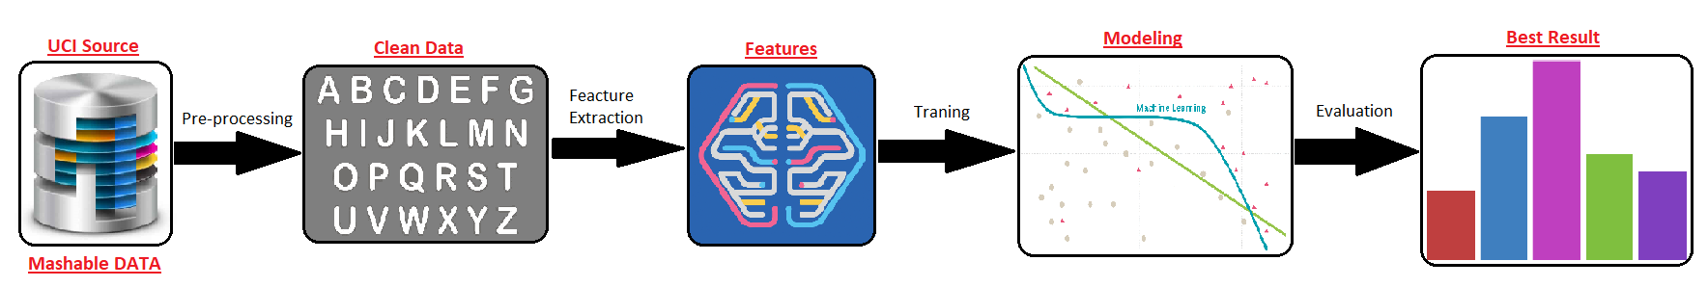

Fig 1: Steps for Model Building

## Problem Statement:

In this project, we are Predicting number of shares that the article will get once it is published And based on number of shares we are deciding the popularity of articles. The goal is to first use data-driven models for predicting what is more likely to happen in the future, and then use modern optimization methods to search for the best possible solution given what can be currently known and predicted.

## Domain:

## Web Analytics

## Data Source:

<https://archive.ics.uci.edu/ml/datasets/Online+News+Popularity>

## Need for Study:

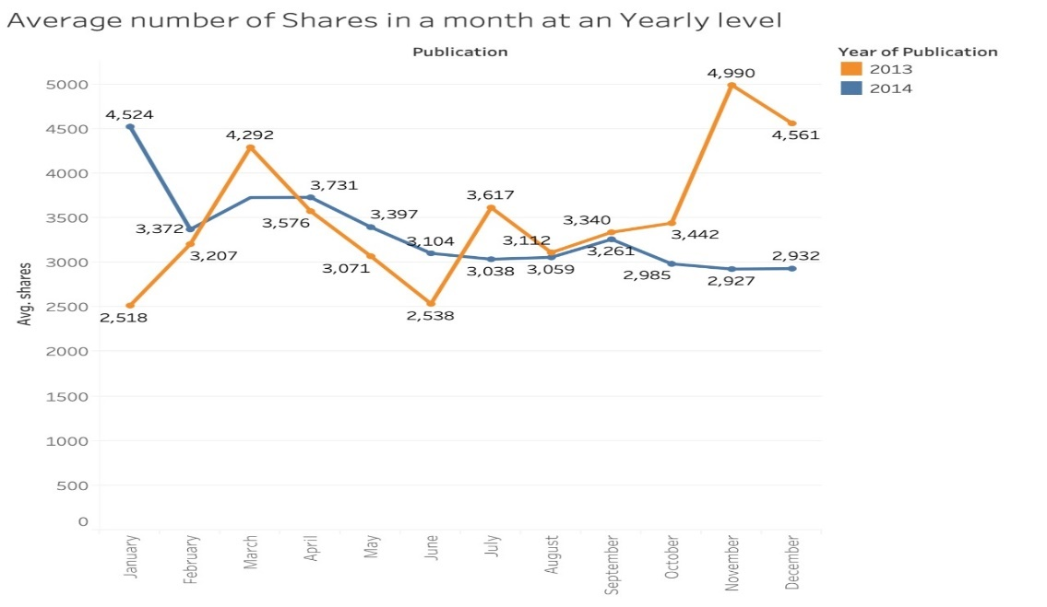

Number of articles in each data channels are getting increased with the advent of technology. We can observe that, in the greater number of articles are getting released in the month of November and March,least in June in the year 2013.

As the year prolongs, number of articles in each data channels are getting increased with the advent of technology. We can observe that, in the greater number of articles are getting released in the month of January, April and October , least in February and August in the year 2014.

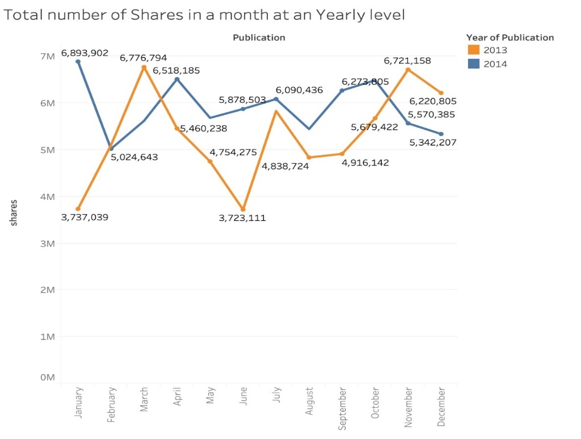

## Data Constraints and Data Information:

The articles were published by Mashable (www.mashable.com) and their content as the rights to reproduce it belongs to them. Hence, this dataset gives some statistics associated with it. The original content be publicly accessed and retrieved using the provided URLs.

|  |  |  |
| --- | --- | --- |
| **Feature Name** | **Feature Description** | **Type of Data** |
| URL | URL of the article | Non-predictive |
| timedelta | Days between the article publication and the dataset acquisition | Non-predictive |
| Shares | Number of shares | Numerical |

**Tokenization:** “Tokens” are usually individual words and “tokenization” is taking a text or set of text and breaking it up into its individual meaningful words i.e., converting sentences to words. Special characters and apostrophes are considered as separate words.

|  |  |  |
| --- | --- | --- |
| **Feature Name** | **Feature Description** | **Type of Data** |
| N_tokens_title | Number of words in the title | Discrete |
| n_tokens_content | Number of words in the content | Numerical |
| average_token_length | Average length of the words in the content. It is the sum of length of each word in the content divided by total number of words in the content. | Numerical |

**Bag of Words (BOW):** In text processing, words of the text represent discrete, categorical features. The mapping from textual data to real valued vectors is called feature extraction. One of the simplest techniques to numerically represent text is Bag of Words. We make the list of unique words in the text corpus called vocabulary. Then we can represent each sentence or document as a vector with each word. Another representation can be counting the number of times each word appears in a document. The most popular approach is using the **TF-IDF** technique.

***Note****: Documents are rows which is collection of terms. Terms are the columns which is collection of words*

**Term Frequency-Inverse Document Frequency (TF-IDF)** technique is a numerical statistic that is intended to reflect how important a word is to a document in a collection or corpus. It is often used as a weighting factor in searches of information retrieval. The TF-IDF value increases proportionally to the number of times a word appears in the document and is offset by the number of documents in the corpus that contain the word, which helps to adjust for the fact that some words appear more frequently in general.

* **Term Frequency (TF)** = (Number of times term t appears in a document)/ (Total number of terms in the document)
* **Inverse Document Frequency (IDF)** = log(N/n), where, N is the number of documents and n is the number of documents a term t has appeared in. The IDF of a rare word is high, whereas the IDF of a frequent word is likely to be low. Thus, having the effect of highlighting words that are distinct. Inverse document frequency factor is incorporated which diminishes the weight of terms that occur very frequently in the document set and increases the weight of terms that occur rarely.

|  |  |  |
| --- | --- | --- |
| **Feature Name** | **Feature Description** | **Type of Data** |
| N_unique_tokens | Rate of unique words in the content | Numerical |
| n_non_stop_words | Rate of non-stop words in the content | Numerical |
| n_non_stop_unique_tokens | Rate of unique non-stop words in the  content | Numerical |

***Note: Stop words*** *— frequent words such as “the, is”, etc. that do not have specific semantic. In total there are 179 stop words in English.*

**Metadata:** They are the brief notes of the data. They are the data that contains information about other data. Metadata of a subject can be an image, year, events, which gives the brief description of the main content of the data. Used for discovery and identification.

**Topic Modeling:** A Topic Model can be defined as an unsupervised technique to discover topics across various text documents.

It is a process to automatically identify topics present in a text object and to derive hidden patterns exhibited by a text corpus. These topics are abstract in nature, i.e., words which are related to each other form a topic. It represents each and every term and document as a vector.

***Note:*** *Topics are cluster of words (similar and related words), documents are cluster of topics, topic is a frequency of words*

**Keywords:** These are words which helps to connect to the main data. These are used based on most frequently used words for quick search by the users.

|  |  |  |
| --- | --- | --- |
| **Feature Name** | **Feature Description** | **Type of Data** |
| Num_keywords | Number of keywords in the metadata | Discrete |
| kw_min_min | Worst keyword (min. shares) | Numerical |
| kw_max_min | Worst keywords (max. shares) | Numerical |
| kw_avg_min | Worst keyword (avg. shares) | Numerical |
| kw_min_max | Best keyword (min. shares) | Numerical |
| kw_max_max | Best keyword (max. shares) | Numerical |
| kw_avg_max | Best keyword (avg. shares) | Numerical |
| Kw_min_avg | Avg. keyword (min. shares) | Numerical |
| kw_max_avg | Avg. keyword (max. shares) | Numerical |
| kw_avg_avg | Avg. keyword (avg. shares) | Numerical |

**Latent Dirichlet Allocation (LDA):** LDA assumes documents are produced from a mixture of topics. Those topics then generate words based on their probability distribution. Given a dataset of documents, LDA backtracks and tries to figure out what topics would create those documents in the first place. LDA is a matrix factorization technique. In vector space, any corpus collection of documents can be represented as a document-term matrix. In our case, the topic model is split into 4 topics. It determines the percentage of probability of each topic being present in the contents. We can observe that percentage probability of each document shares with all the 5 LDA’s.

|  |  |  |
| --- | --- | --- |
| **Feature Name** | **Feature Description** | **Type of Data** |
| LDA_00 | Closeness to LDA topic 0 | Numerical |
| LDA_01 | Closeness to LDA topic 1 | Numerical |
| LDA_02 | Closeness to LDA topic 2 | Numerical |
| LDA_03 | Closeness to LDA topic 3 | Numerical |
| LDA_04 | Closeness to LDA topic 4 | Numerical |

|  |  |  |  |  |
| --- | --- | --- | --- | --- |
| **Feature Name** | **Feature Description** | | **Type of Data** | |
| num_hrefs | It gives the count of number of links in the  news link | | Numerical | |
| num_self_hrefs | It gives the number of links to other  articles published by Mashable | | Numerical | |
| num_imgs | It is the number of images related to the  article | | Numerical | |
| num_videos | It is the number of videos related to the  article | | Numerical | |
| self_reference_min_shares | Min. shares of referenced articles in  Mashable | | Numerical | |
| self_reference_max_shares | Max. shares of referenced articles in  Mashable | | Numerical | |
| self_reference_avg_shares | Avg. shares of referenced articles in  Mashable | | Numerical | |
| weekday_is_Monday | Was the article published on a Monday? | | Categorical | |
| weekday_is_Tuesday | Was the article published on a Tuesday? | | Categorical | |
| weekday_is_Wednesday | | Was the article published on a  Wednesday? | | Categorical |
| weekday_is_Thursday | | Was the article published on a Thursday? | | Categorical |
| weekday_is_Friday | | Was the article published on a Friday? | | Categorical |
| weekday_is_Saturday | | Was the article published on a Saturday? | | Categorical |
| weekday_is_Sunday | | Was the article published on a Sunday? | | Categorical |
| is_weekday | | Was the article published on the weekday? | | Categorical |
| is_weekend | | Was the article published on the weekend? | | Categorical |

**Data Channel:** It is the column categorizes the data based on such as lifestyle, entertainment, business, social media, technology and world (economics, politics etc.)

|  |  |  |
| --- | --- | --- |
| **Feature Name** | **Feature Description** | **Type of Data** |
| data_channel_is_lifestyle | Is data channel ‘Lifestyle’? | Categorical |
| data_channel_is_entertainment | Is data channel ‘Entertainment’? | Categorical |
| data_channel_is_bus | Is data channel ‘Business’? | Categorical |
| data_channel_is_social media | Is data channel ‘Social Media’? | Categorical |
| data_channel_is_tech | Is data channel ‘Tech’? | Categorical |
| data_channel_is_world | Is data channel ‘World’? | Categorical |

**Subjectivity:** Language can contain expressions that are objective or subjective. Objective expressions are facts.

**Subjective** expressions are opinions that describe people’s feelings towards a specific subject or topic.

***Ex:*** *This is a phone is good. (is subjective as it expresses an opinion towards the taste of the phone.)*

|  |  |  |  |  |
| --- | --- | --- | --- | --- |
| **Feature Name** | **Feature Description** | | **Type of Data** | |
| global_Subjectivity | Text subjectivity | | Numerical | |
| global_rate_positive_words | Rate of positive words in the content | | Numerical | |
| global_rate_negative_words | Rate of negative words in the content | | Numerical | |
| rate_positive_words | Rate of positive words among non-  neutral tokens | | Numerical | |
| rate_negative_words | | Rate of negative words among non-  neutral tokens | | Numerical |
| title_subjectivity | | Title subjectivity | | Numerical |
| abs_title_subjectivity | | Absolute subjectivity level | | Numerical |

**Sentiment Analysis:** To determine, from a text corpus, whether the sentiment towards any topic or product etc. is positive, negative, or neutral.

Sentiment analysis has compound score considers only positive and negative polarity score and it ignores neutral score.

**Polarity:** to identifying sentiment orientation (positive, neutral, and negative) in written or spoken language. It ranges between -1 and +1. They are emotions which is expressed on tangible items.

Positive Score = 𝑁𝑜 𝑜𝑓 𝑡𝑖𝑚𝑒𝑠 𝑜𝑐𝑐𝑢𝑟𝑟𝑒𝑛𝑐𝑒 𝑜𝑓 𝑝𝑜𝑠𝑖𝑡𝑖𝑣𝑒 𝑤𝑜𝑟𝑑×𝑆𝑒𝑛𝑡𝑖𝑚𝑒𝑛𝑡 𝑉𝑎𝑙𝑢𝑒𝑠 𝑜𝑓 𝑃𝑜𝑠𝑖𝑡𝑖𝑣𝑒 𝑊𝑜𝑟𝑑

𝑂𝑣𝑒𝑟𝑎𝑙𝑙 𝑤𝑜𝑟𝑑𝑠

Negative Score = 𝑁𝑜 𝑜𝑓 𝑡𝑖𝑚𝑒𝑠 𝑜𝑐𝑐𝑢𝑟𝑟𝑒𝑛𝑐𝑒 𝑜𝑓 𝑛𝑒𝑔𝑎𝑡𝑖𝑣𝑒 𝑤𝑜𝑟𝑑×𝑆𝑒𝑛𝑡𝑖𝑚𝑒𝑛𝑡 𝑉𝑎𝑙𝑢𝑒𝑠 𝑜𝑓 𝑛𝑒𝑔𝑎𝑡𝑖𝑣𝑒 𝑊𝑜𝑟𝑑

𝑂𝑣𝑒𝑟𝑎𝑙𝑙 𝑤𝑜𝑟𝑑𝑠

Sentence Polarity = Positive score – Negative score

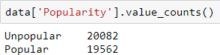

|  |  |  |
| --- | --- | --- |
| **Feature Name** | **Feature Description** | **Type of Data** |
| global_sentiment_polarity | Text sentiment polarity | Numerical |
| avg_positive_polarity | Avg. polarity of positive words | Numerical |
| min_positive_polarity | Min. polarity of positive words | Numerical |
| max_positive_polarity | Max. polarity of positive words | Numerical |
| avg_negative_polarity | Avg. polarity of negative words | Numerical |
| min_negative_polarity | Min. polarity of negative words | Numerical |
| max_negative_polarity | Max. polarity of negative words | Numerical |
| title_sentiment_polarity | Title polarity | Numerical |
| abs_title_sentiment_polarity | Absolute polarity level | Numerical |

## Creating Target Column:

There are 39644 observations/articles which are collected from Mashable website. There are 61 attributes and no null values. Total number of shares are predicted by the company based in the content, impact of days and data channels. Using ‘qcut’ from pandas library we have categorized number of shares into ‘Popular’ and ‘Unpopular’.



Data Pre-Processing:

**Imputing NaN values using KNN Imputer**

**Standardizing selected features**

**Select truly continuous features from the dataset and check Skewness**

**Replacing Outliers using IQR method with NaN Values**

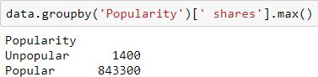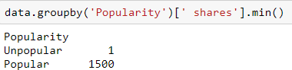

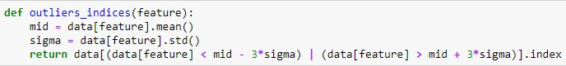As we can observe that under ‘Popular’ category there are come extreme values that will right skew that data. Hence, to get good accuracy score and to reduce the error we have to treat those extreme values to get better result. For detecting the extreme values, we used IQR method.

3 sigma zone will remove the outliers whose values is not in between ±3. Since number of shares has outliers, it has been treated using IQR method. The number of observations reduced from 39644 to 39336. As a result, the extreme values got eliminated.

**Imputing NaN values using KNN Imputer:** The assumption behind using KNN for missing values is that a point

value can be approximated by the values of the points that are closest to it, based on other variables.

**Standardizing selected features:**  standardization will "**standardize**" your values according to **standard**

**deviation** as a reference: your values won't have any boundary (from 0.0 to infinity), but the value 1.0 will

be equal to the standard deviation, 2.0 will be 2x the standard deviation, etc. So standardization is a way

to convert your values to z-scores



# Chapter 3 - Exploratory Data Analysis

The purpose of exploratory data analysis is two-fold:

* to understand the data in terms of Visitor session information and visitor pageview information across various independent variables
* Get insights on various features.

## Understand data distribution

### Baseline Popularity

### 

We can observe that of the total number of shares 20,082 of shares are unpopular and 19,562 are popular.

EDA is process in which visualization is done on each valuable to check how they are inter-related and what is the inference we get from the plot which will helpful to bring insights that will help to drive the business. In our data set, more the number of shares more is the revenue. Hence, it is important to study all the attributes which corresponds or which are related to dependent variable. Since majority of the data is derived from text mining it is important to study how each derived attribute from text mining corresponds to increase in number of shares and popularity.

**DATA CLEANING FOR TEXT MINING:**

## 

To make a blog powerful we need have some commanding words which will appeal the readers. Maximum if such words in an article will make them more intensive. We can observe from the above scatter plots that the rate of unique token in content and title much be more and, in our case, it should be in the range of average token length should be between 4 to 7. When we take non-stop words the rate percentage should be more to make an article popular and, in our case, it ranges between 50% to 90%.

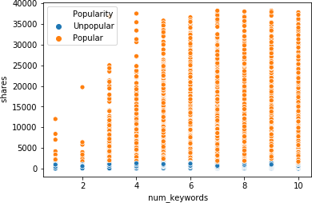**TOPIC MODELING USING LDA:**

## 

We can observe from the share vs number of keywords plot that more the number of key words more an article will be shares. In our case the topic keywords range between 4 to 10 which has the maximum number of shares. LDA gives the percentage of probability of each topic of an article being present when n-gram is given as 5.

## **SUBJECTIVITY:**

## 

## 

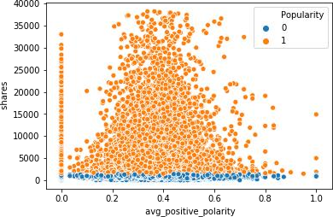As the subjectivity expressions are opinions that describe people’s feelings towards a specific subject or topic. It represents individual sentences to determine whether a sentence expresses an opinion or not. Hence, we can see that the rate positive words range between 50% to 90% which gives a positive feeling on the articles. On the contrary is the rate of negative words which range between 10% to 50% which gives the negative feelings.

## **SENTIMENT POLARITY:**

Polarity stresses on emotions on the tangile items. They are the general sentiment of of what article is about. It is expressed in percentage. In our case, we can observe that for positive polarity the range should be between 0.3 to 0.5 and negative sentiment polarity should be between -0.2 to to -0.5.Hence we can conclude by saying an article which has only positive or negative polarity will have minimum number of shares. Hence, we should have both positive and negative polarity. This cannot always hold good.

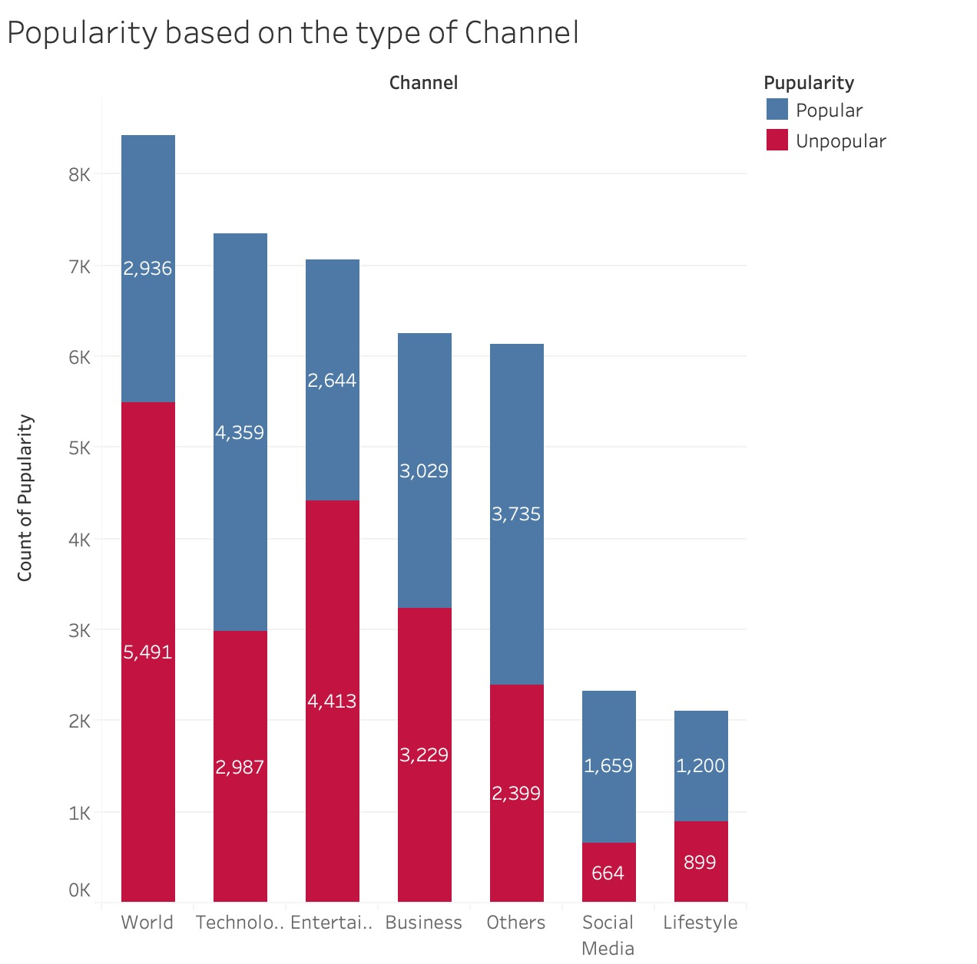

## This is the graph which represents types of data channels vs number of articles in each data types. World has highest number of articles getting published. But maximum count can be that they are not popular. Lifestyle had a greater number of popular articles. Social media has minimal number of articles. Hence, we can say that articles under lifestyle, world and technology has more articles.

## 

## The graph represents types of data channels vs average shares of the articles in each data channel. We can see that maximum average share is with articles related to lifestyle though world has a greater number of articles getting published. Second highest shares of articles are on entertainment. Least is on business.

## 

## **IMAGES AND VIDEOS:**

## 

* + - Image count range between 1-25 Video count range between 1-4
    - Lesser the image sharing is high Lesser the videos sharing is high

## **NUMBER OF LINKS IN ARTICLES AND LINKS TO OTHER ARTICLES:**

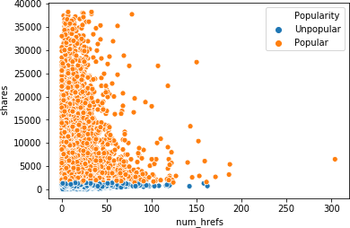

* + - Link count range between 0-40 Link for other articles count range between 1-4
    - Lesser the links sharing is high

From this we can infer that more the number of links in an article reader will tend to read those articles which will affect on the original article as the reader may then to ignore or forget to read the articles.

# **DAY WISE SHARE:**

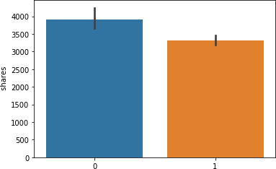Weekday (0): More share Weekend Weekday(1): Less Share

## The number of articles getting published is more on Wednesdays and Tuesday. Less number of articles are published on Saturday and Sunday. Hence, we can say that the number of shares of each article is more on weekdays when compared to weekend.

## **MONTH WISE SHARES:**

## 

As the year prolongs, number of articles in each data channels are getting increased with the advent of technology. We can observe that, in the greater number of articles are getting released in the month of October least in December in the year 2014.

**FEATURE SELECTION:**

|  |  |  |  |  |  |  |  |
| --- | --- | --- | --- | --- | --- | --- | --- |
| **OLS Regression Results** | |  |  | | |  | |
| **Dep. Variable:** | | shares | **R-squared:** | | | 0.058 | |
| **Model:** | | OLS | **Adj. R- squared:** | | | 0.057 | |
| **Method:** | | Least Squares | **F-statistic:** | | | 43.12 | |
| **Date:** | | Wed, 11  Dec 2019 | **Prob (F- statistic):** | | | 0.00 | |
| **Time:** | | 23:13:07 | **Log- Likelihood:** | | | -4.2617e+05 | |
| **No. Observations:** | | 39644 | **AIC:** | | | 8.525e+05 | |
| **Df Residuals:** | | 39586 | **BIC:** | | | 8.530e+05 | |
| **Df Model:** | 57 | | |  |  | |  | |  |  |
| **Covariance Type:** | nonrobust | | |  |  | |  | |  |  |
|  | **coef** | | | **std err** | **t** | | **P>|t|** | | **[0.025** | **0.975]** |
| **const** | -8.506e+05 | | | 5.12e+06 | -0.166 | | 0.868 | | - 1.09e+07 | 9.18e+06 |
| **n_tokens_title** | 88.2324 | | | 28.148 | 3.135 | | 0.002 | | 33.061 | 143.403 |
| **n_tokens_content** | 0.4597 | | | 0.219 | 2.095 | | 0.036 | | 0.030 | 0.890 |
| **n_unique_tokens** | 3973.8776 | | | 1883.545 | 2.110 | | 0.035 | | 282.084 | 7665.671 |
| **n_non_stop_words** | -1123.8373 | | | 5803.035 | -0.194 | | 0.846 | | - 1.25e+04 | 1.03e+04 |
| **n_non_stop_unique_tokens** | -943.4342 | | | 1599.824 | -0.590 | | 0.555 | | - 4079.128 | 2192.260 |
| **num_hrefs** | 18.5773 | | | 6.587 | 2.820 | | 0.005 | | 5.667 | 31.488 |
| **num_self_hrefs** | -34.3386 | | | 17.503 | -1.962 | | 0.050 | | -68.645 | -0.032 |
| **num_imgs** | 9.9232 | | | 8.779 | 1.130 | | 0.258 | | -7.284 | 27.130 |
| **num_videos** | 3.8519 | | | 15.463 | 0.249 | | 0.803 | | -26.456 | 34.160 |
| **average_token_length** | -465.2246 | | | 238.444 | -1.951 | | 0.051 | | -932.581 | 2.132 |
| **data_channel_is_lifestyle** | -866.8313 | | | 387.477 | -2.237 | | 0.025 | | - 1626.296 | -107.367 |
| **data_channel_is_entertainment** | -779.3576 | | | 250.753 | -3.108 | | 0.002 | | - 1270.840 | -287.875 |
| **data_channel_is_bus** | -461.3687 | | | 375.834 | -1.228 | | 0.220 | | - 1198.013 | 275.276 |
| **data_channel_is_socmed** | -1321.4819 | | | 366.055 | -3.610 | | 0.000 | | - 2038.959 | -604.005 |

|  |  |  |  |  |  |  |
| --- | --- | --- | --- | --- | --- | --- |
| **data_channel_is_tech** | -992.7337 | 364.826 | -2.721 | 0.007 | - 1707.802 | -277.665 |
| **data_channel_is_world** | -398.9130 | 369.500 | -1.080 | 0.280 | - 1123.142 | 325.316 |
| **num_keywords** | 4.5243 | 36.477 | 0.124 | 0.901 | -66.972 | 76.021 |
| **kw_min_min** | 0.4199 | 1.594 | 0.263 | 0.792 | -2.705 | 3.545 |
| **kw_max_min** | 0.0448 | 0.049 | 0.910 | 0.363 | -0.052 | 0.141 |
| **kw_avg_min** | -0.0612 | 0.302 | -0.202 | 0.840 | -0.654 | 0.531 |
| **kw_min_max** | -0.0014 | 0.001 | -1.207 | 0.227 | -0.004 | 0.001 |
| **kw_max_max** | -0.0002 | 0.001 | -0.283 | 0.777 | -0.001 | 0.001 |
| **kw_avg_max** | -0.0002 | 0.001 | -0.198 | 0.843 | -0.002 | 0.001 |
| **kw_min_avg** | -0.2937 | 0.074 | -3.952 | 0.000 | -0.439 | -0.148 |
| **kw_max_avg** | -0.1133 | 0.025 | -4.541 | 0.000 | -0.162 | -0.064 |
| **kw_avg_avg** | 0.9789 | 0.142 | 6.878 | 0.000 | 0.700 | 1.258 |
| **self_reference_min_shares** | 0.0250 | 0.007 | 3.387 | 0.001 | 0.011 | 0.040 |
| **self_reference_max_shares** | 0.0054 | 0.004 | 1.341 | 0.180 | -0.002 | 0.013 |
| **self_reference_avg_sharess** | -0.0078 | 0.010 | -0.763 | 0.445 | -0.028 | 0.012 |
| **weekday_is_monday** | -1.497e+05 | 9.03e+05 | -0.166 | 0.868 | - 1.92e+06 | 1.62e+06 |
| **weekday_is_tuesday** | -1.501e+05 | 9.03e+05 | -0.166 | 0.868 | - 1.92e+06 | 1.62e+06 |
| **weekday_is_wednesday** | -1.499e+05 | 9.03e+05 | -0.166 | 0.868 | - 1.92e+06 | 1.62e+06 |
| **weekday_is_thursday** | **-1.502e+05** | **9.03e+05** | **-0.166** | **0.868** | **- 1.92e+06** | **1.62e+06** |
| **weekday_is_friday** | **-1.503e+05** | **9.03e+05** | **-0.167** | **0.868** | **- 1.92e+06** | **1.62e+06** |
| **weekday_is_saturday** | **-5.009e+04** | **3.01e+05** | **-0.166** | **0.868** | **-6.4e+05** | **5.4e+05** |
| **weekday_is_sunday** | **-5.028e+04** | **3.01e+05** | **-0.167** | **0.867** | **-6.4e+05** | **5.39e+05** |
| **is_weekend** | **-1.004e+05** | **6.02e+05** | **-0.167** | **0.868** | **- 1.28e+06** | **1.08e+06** |
| **LDA_00** | **9.989e+05** | **6.02e+06** | **0.166** | **0.868** | **- 1.08e+07** | **1.28e+07** |
| **LDA_01** | **9.991e+05** | **6.02e+06** | **0.166** | **0.868** | **- 1.08e+07** | **1.28e+07** |
| **LDA_02** | **9.989e+05** | **6.02e+06** | **0.166** | **0.868** | **- 1.08e+07** | **1.28e+07** |
| **LDA_03** | **9.995e+05** | **6.02e+06** | **0.166** | **0.868** | **- 1.08e+07** | **1.28e+07** |
| **LDA_04** | **9.991e+05** | **6.02e+06** | **0.166** | **0.868** | **- 1.08e+07** | **1.28e+07** |
| **global_subjectivity** | **1426.4018** | **835.471** | **1.707** | **0.088** | **-211.142** | **3063.946** |
| **global_rate_positive_words** | **-1.026e+04** | **7035.003** | **-1.458** | **0.145** | **-2.4e+04** | **3531.478** |
| **global_rate_negative_words** | **-1321.3326** | **1.34e+04** | **-0.098** | **0.922** | **- 2.76e+04** | **2.5e+04** |
| **rate_positive_words** | **1023.2121** | **5671.050** | **0.180** | **0.857** | **- 1.01e+04** | **1.21e+04** |
| **rate_negative_words** | **1369.5059** | **5715.911** | **0.240** | **0.811** | **- 9833.817** | **1.26e+04** |
| **global_sentiment_polarity** | **686.7758** | **1637.146** | **0.419** | **0.675** | **- 2522.070** | **3895.621** |

|  |  |  |  |  |  |  |
| --- | --- | --- | --- | --- | --- | --- |
| **avg_positive_polarity** | -1256.7904 | 1341.715 | -0.937 | 0.349 | - 3886.584 | 1373.003 |
| **min_positive_polarity** | -1533.6508 | 1123.394 | -1.365 | 0.172 | - 3735.530 | 668.228 |
| **max_positive_polarity** | 318.3881 | 423.194 | 0.752 | 0.452 | -511.082 | 1147.858 |
| **avg_negative_polarity** | -1601.4158 | 1235.626 | -1.296 | 0.195 | - 4023.272 | 820.440 |
| **min_negative_polarity** | 86.1288 | 450.543 | 0.191 | 0.848 | -796.947 | 969.204 |
| **max_negative_polarity** | -254.7444 | 1027.482 | -0.248 | 0.804 | - 2268.633 | 1759.144 |
| **title_subjectivity** | -269.1278 | 269.204 | -1.000 | 0.317 | -796.775 | 258.519 |
| **title_sentiment_polarity** | -14.1856 | 245.944 | -0.058 | 0.954 | -496.241 | 467.870 |
| **abs_title_subjectivity** | 338.6001 | 357.508 | 0.947 | 0.344 | -362.125 | 1039.325 |
| **abs_title_sentiment_polarity** | 650.4900 | 388.529 | 1.674 | 0.094 | -111.035 | 1412.015 |
| **Popularity** | 4665.0486 | 120.992 | 38.557 | 0.000 | 4427.902 | 4902.195 |

From OLS summary we can observe that most of the variable are not significant except [' n_tokens_title', 'n_tokens_content', 'n_unique_tokens', 'n_non_stop_words', 'num_hrefs', 'data_channel_is_lifestyle', 'data_channel_is_entertainment', 'data_channel_is_bus', 'data_channel_is_socmed', 'data_channel_is_tech', 'data_channel_is_world', 'kw_min_avg', 'kw_max_avg', 'kw_avg_avg', 'self_reference_min_shares', 'weekday_is_friday', 'is_weekend', 'LDA_03', 'avg_negative_polarity', 'Popularity'].

Since most of the attributes are derived from text mining all the attributes are interlinked. Hen ce, while building the model it is important to consider all the attributes.

**Using Statistical Model:**

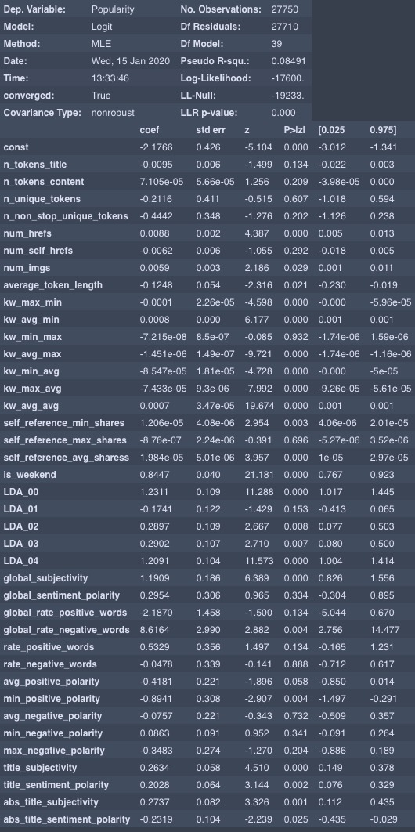

We performed the statistical model using Logit because of the classification problem. If we look at the p-values which lie above 0.05 for every feature highlights the insignificance.

This is a statistical way of performing the feature selection and we also have a machine learning method for feature selection for which we’ll perform Recursive Feature Elimination.

# **MODEL BUILDING:**

In this project, feature selection techniques are applied to improve the classification performance and/or scalability of the system. Thus, we aim to investigate if better or similar classification performance can be achieved with a smaller number of features. We have considered all the attributes except ‘shares’ as we have derived binary class ‘Popular’ and ‘Unpopular’ from number of shares. Without removing the outlier base model logistic regression gave accuracy of 36%. Hence, we treated outlier using IQR and scaling the accuracy of the algorithm started increasing.

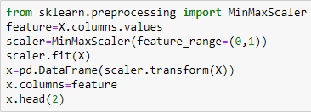

We will use the following model performance measures to check the model accuracy.

**Accuracy:** Accuracy is the number of correct predictions made by the model by the total number of records. The higher the accuracy the better the model

**Sensitivity or recall:** Sensitivity (Recall or True positive rate) is calculated as the number of correct positive predictions divided by the total number of positives. It is also called recall or true positive rate (TPR). For a model sensitivity or recall should be more.

**Specificity:** Specificity (true negative rate) is calculated as the number of correct negative predictions divided by the total number of negatives.

**Precision:** Precision (Positive predictive value) is calculated as the number of correct positive predictions divided by the total number of positive predictions. In the above case how many correct popular models were predicted as popular.

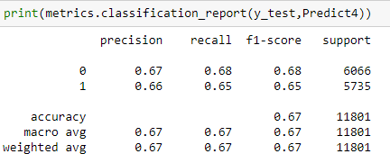

|  |  |  |  |  |  |  |  |
| --- | --- | --- | --- | --- | --- | --- | --- |
| **Models** | **Cross Validation Train Test Split (70:30)**  **(k_fold = 7)** | | | | | | |
| **ROC_AUC** | **Train Accuracy** | **Test Accuracy** | **Precision** | | **Recall** | |
| **Un-Popular** | **Popular** | **Un-Popular** | **Popular** |
| **Logistic Regression** | **68.82%** | **68.96%** | **63.86%** | **65.00%** | **63.00%** | **66.00%** | **62.00%** |
| **KNN** | **59.07%** | **73.00%** | **59.00%** | **61.00%** | **59.00%** | **63.00%** | **56.00%** |
| **Decision Tree** | **57.91%** | **98.00%** | **57.00%** | **59.00%** | **57.00%** | **59.00%** | **57.00%** |
| **Random Forest** | **67.20%** | **67.90%** | **68.00%** | **61.00%** | **63.00%** | **71.00%** | **52.00%** |
| **Bagged DT** | **67.04%** | **100%** | **62.00%** | **59.05%** | **57.45%** | **59.90%** | **57.00%** |
| **Bagged Log Reg** | **68.79%** | **63.95%** | **63.95%** | **65.00%** | **63.00%** | **66.00%** | **62.00%** |
| **Ada Boost Log Reg** | **65.48%** | **60.82%** | **61.38%** | **62.00%** | **61.00%** | **64.00%** | **58.00%** |
| **Ada Boost DT** | **70.59%** | **66.71%** | **65.92%** | **66.00%** | **65.00%** | **68%** | **64.00%** |
| **Ada Boost RF** | **69.72%** | **100%** | **64.34%** | **65.00%** | **64.00%** | **66.00%** | **62.00%** |
| **Gradient Boosting** | **72.79%** | **68.52%** | **66.65%** | **67.00%** | **66.00%** | **68.00%** | **65.00%** |

Gradient boost algorithm has an accuracy of 72.79% with training accuracy of 68.52% and testing accuracy of 66.65%. Precision score of popular and unpopular are 67% and 66% respectively. Recall score is 68% and 65%. Hence, gradient boost algorithm is the better fit model for the data set.

We also observed that even without scaling there was not much change in the accuracy score.

## **Confusion Matrix:**

## 

## 

## 

# Chapter 4 - Conclusions



In this project, we are working on retail analytics, using a dataset on Mashable a media company which publishes blogs and articles. The main objective is to predict whether the article will be popular or not depending on various features like the number of words the article consists or the number of images, videos or links were shared.

While working on visualizing the features we found that the there were not much correlation between the dependent and independent feature but when each column were checked against shares, we got some insights like when the title had neither less nor more number of words in the title, that particular article got more number of shares. Another observation was when the words in content were in the range 6-15 the articles were popular. There were some extreme values which was driving down the accuracy of the models. Using IQR we removed those extreme values and normalized the data with min max scaler. PCA had no impact on improving the model accuracy. Gradient boost algorithm worked will though there was not much relation between the attributes.

• The number of keywords in the metadata influences the shares to a margin. The higher the value the better the shares chances. A value upward of 5 is recommended.

• The content should be less than 1500 words. The lesser the better.

• Title should be between 6 - 17 words.

• Unique words should be between 0.3 - 0.8%

• No. of links between 1 and 40 is preferred.

• Images - 0 to 3

• Videos – 0 to 25

• Minimal images and videos will make an article more interesting

• More articles are getting published on World data channel.

• Lifestyle and entertainment-based articles are preferred more by people.

• Best popular articles are usually posted on Mondays and Wednesday (and a bit of Tuesdays).

• Sundays and Saturdays (Weekends generally) are the worsts days to publish an article.

• Articles that talks about current trending are better for shares



# Chapter 5– Recommendations and Actionable Insights



* + Conversion Rate of New visitors are high when compared to Returning customer. In order to bring new visitors to the website below actions needs to be taken.
    - Discounting is not a long-term strategy but it can be highly effective in driving new customers to your store. Figure out your customer acquisition cost and from that, how much of a discount (on a limited amount of quantity/product) you can afford to offer in order to acquire new customers.
    - Partnering with a non-competitive but audience-complementary partner can be a highly effective way of acquiring new customers. This can be something as simple as a traffic exchange – partnering with a highly-trafficked site in your customer’s domain, putting up a banner to drive traffic to your shop, and paying the partner either a cut of the cart revenue or a flat fee for every customer acquired via the partner banner.
    - Writing authoritative, interesting content in your online shop’s contextual domain will pay huge dividends over the long term. Targeted content will help boost your site’s SEO bringing in new customers organically, and will also encourage your existing visitors to share your content more. Every online shop should have blog content as part of its marketing strategy
    - A super effective way to capture a whole new customer segment is to offer a whole new product or service! This doesn’t even need to be complicated, it could simply be a repositioning, repackaging or even repricing of an existing product.
    - The best and arguably most valuable method of customer acquisition is when existing customers *refer a friend*. When this method works really well, all the marketing is done by your existing customers meaning you can focus on running your online store instead of spending time bringing people to it. Referrals can happen organically via Word of Mouth marketing (focus on great products, great prices and excellent customer) but you can also implement a referral marketing program**.**
  + Number of Returning customer to website is high but the conversion rate is low when compared to new customers. Retargeting is a effective way to generate a revenue.
    - Target Individuals based on the searches they conduct on Web Brower.
    - Target Individuals based on specific products viewed, actions taken and actions not taken ( abandoning the cart )
    - Target the customer based on the source they arrived to the website.
    - Target customers who are interacting with email programs.
    - Target customers who have visited a partner site that shares similar product.
    - Target the customers who have interact with your distributed content (custom facebook page , expandable ad unit.)
    - Target individuals who consume similar content to your existing customers.
  + Decrease the bounce rate of page and increase page value for more revenue generation.



# Chapter 6 - References and Bibliography



* S. Olcay, PolatMete Katircioglu ,Yomi Kastro. Real-time prediction of online shoppers’

purchasing intention using multilayer perceptron and LSTM recurrent neural networks

* Exploration of shopping orientations and online purchase intention. European Journal of Marketing, 37(11/12), 2003.
* Yi Jin Lim, Abdullah Osman, Shahrul Nizam Salahuddin, Abdul Rahim Romle, Safizal Abdullah Factors Influencing Online Shopping Behavior: The Mediating Role of Purchase Intention.
* Arun Thamizhvanan, M.J. Xavier. Determinants of customers' online purchase intention: an empirical study in India.

|  |
| --- |
| Chapter 7 - Appendix |
| Detailed data dictionary |

|  |  |
| --- | --- |
| **Feature Name** | **Feature Description** |
| url | URL of the article (non-predictive) |
| Timedelta | Days between the article publication and the dataset acquisition (non-predictive) |
| n_tokens_title | Number of words in the title |
| n_tokens_content | Number of words in the content |
| n_unique_tokens | Rate of unique words in the content |
| n_non_stop_words | Rate of non-stop words in the content |
| n_non_stop_unique_tokens | Rate of unique non-stop words in the content |
| num_hrefs | Number of links |
| num_self_hrefs | Number of links to other articles published by Mashable |
| num_imgs | Number of images |
| average_token_length: | Average length of the words in the content |
| kw_min_max: | Best keyword (min. shares) |
| num_videos: | Number of videos |
| average_token_length: | Average length of the words in the content |
| num_keywords: | Number of keywords in the metadata |
| data_channel_is_lifestyle: | Is data channel 'Lifestyle'? |
| data_channel_is_entertainment: | Is data channel 'Entertainment'? |
| data_channel_is_bus: | Is data channel 'Business'? |
| data_channel_is_socmed: | Is data channel 'Social Media'? |
| data_channel_is_tech: | Is data channel 'Tech'? |
| data_channel_is_world: | Is data channel 'World'? |
| kw_min_min: | Worst keyword (min. shares) |
| kw_max_min: | Worst keyword (max. shares) |
| kw_avg_min: | Worst keyword (avg. shares) |
| 39. LDA_00: | Closeness to LDA topic 0 |
| LDA_01: | Closeness to LDA topic 1 |

|  |  |
| --- | --- |
| LDA_02: | Closeness to LDA topic 2 |
| LDA_03: | Closeness to LDA topic 3 |
| LDA_04: | Closeness to LDA topic 4 |
| global_subjectivity: | Text subjectivity |
| global_sentiment_polarity: | Text sentiment polarity |
| rate_positive_words: | Rate of positive words among non-neutral tokens |
| global_rate_positive_words: | Rate of positive words in the content |
| global_rate_negative_words: | Rate of negative words in the content |
| abs_title_sentiment_polarity: | Absolute polarity level |
| rate_negative_words: | Rate of negative words among non-neutral tokens |
| avg_positive_polarity: | Avg. polarity of positive words |
| min_positive_polarity: | Min. polarity of positive words |
| max_positive_polarity: | Max. polarity of positive words |
| avg_negative_polarity: | Avg. polarity of negative words |
| min_negative_polarity: | Min. polarity of negative words |
| max_negative_polarity: | Max. polarity of negative words |
| Title_subjectivity: | Title subjectivity |
| title_sentiment_polarity: | Title polarity |
| abs_title_subjectivity: | Absolute subjectivity level |
| shares: | Number of shares(Target) |